**Assignment 2: Backup and Restore - Using Mongo Dump and Restore, Export, Import (Scenario - All Database, Single Database with all tables, Single database with single table)**

Data Added:

use db1

db.table1.insertMany([

{ "_id" : 1, "name" : "Ajay", "status": "active", "level": 9,"score":99},

{ "_id" : 2, "name" : "Priya", "status": "inactive", "level": 5,"score":88}

])

db.table2.insertMany([

{ "_id" : 1, "name" : "Ashish", "status": "active", "level": 10,"score":100},

{ "_id" : 2, "name" : "Santwana", "status": "inactive", "level": 8,"score":50}

])

use db2

db.table3.insertMany([

{ "_id" : 1, "name" : "Amruta", "status": "active", "level": 1,"score":40},

{ "_id" : 2, "name" : "Avadhoot", "status": "inactive", "level": 4,"score":60}

])

db.table4.insertMany([

{ "_id" : 1, "name" : "Vaishnavi", "status": "active", "level": 8,"score":8},

{ "_id" : 2, "name" : "Abhishek", "status": "inactive", "level": 8,"score":9}

])

**Single collection backup:**

Collection name: table1

mongodump --collection table1 --db db1 --out=/home/ec2-user/table1-output-file --ssl --host forassign3b.cluster-cia4bvgv8e4r.ap-southeast-1.docdb.amazonaws.com:27017 --sslCAFile global-bundle.pem --username root --password administrator

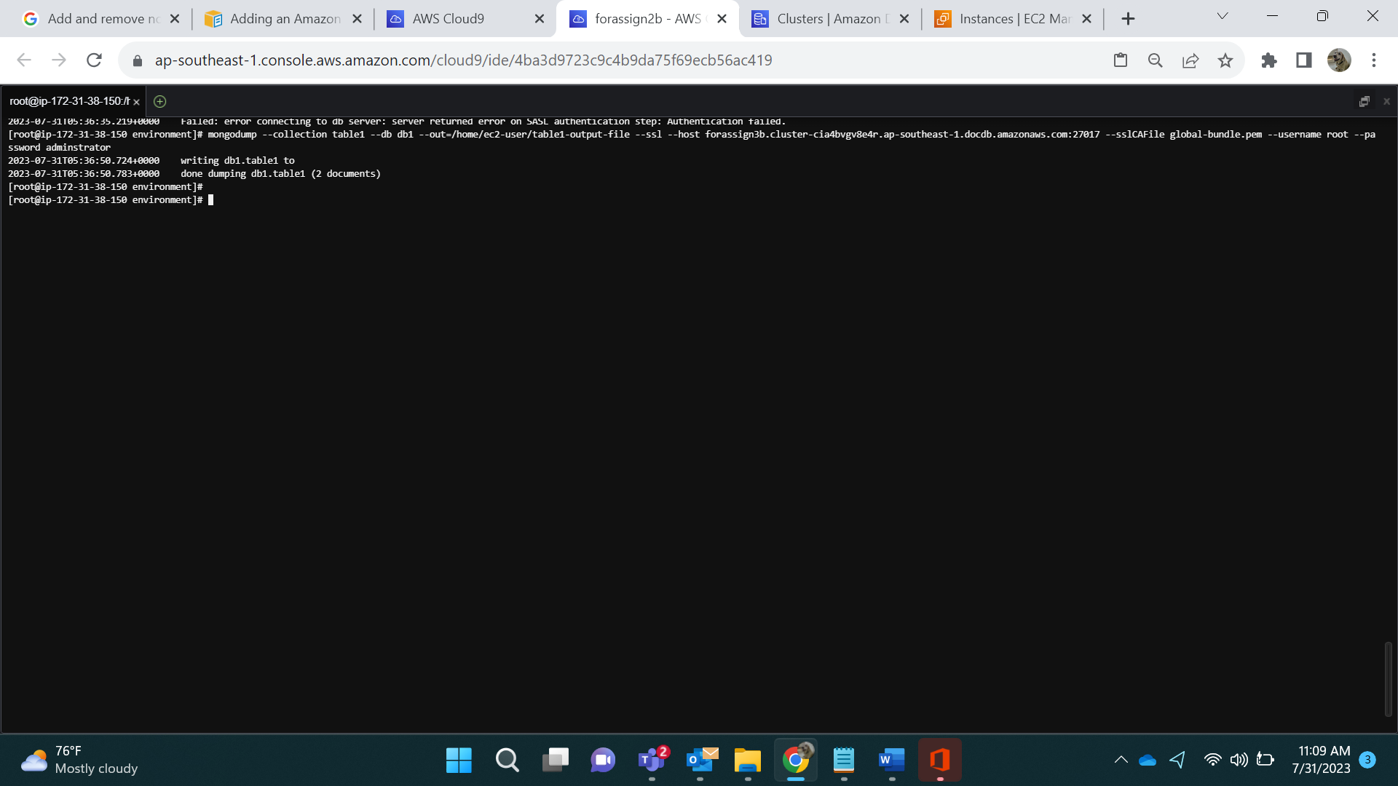

Location: cd/home/ec2-user/table1-output-file/db1

ls

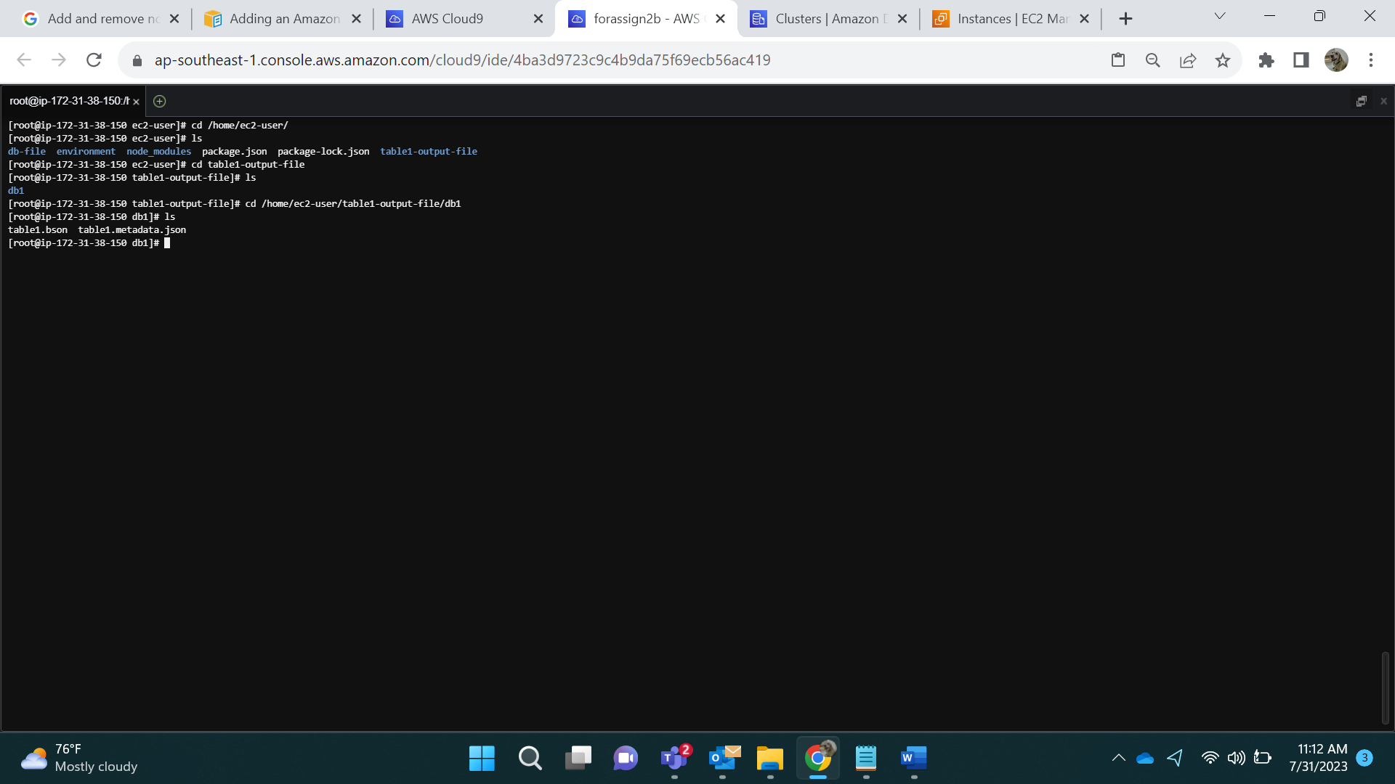

Backup generated two files

1. Table1.metadata.json
2. Table1.bson

Table1.metadata.json files contain metadata of customers collection and Table1.bson files contain data of table1 collection

**Single database backup:**

Under db1 database we have 2 collections as shown below

mongodump --db db1 --out=/home/ec2-user/db1-output-file --ssl --host forassign3b.cluster-cia4bvgv8e4r.ap-southeast-1.docdb.amazonaws.com:27017 --sslCAFile global-bundle.pem --username root --password adminstrator

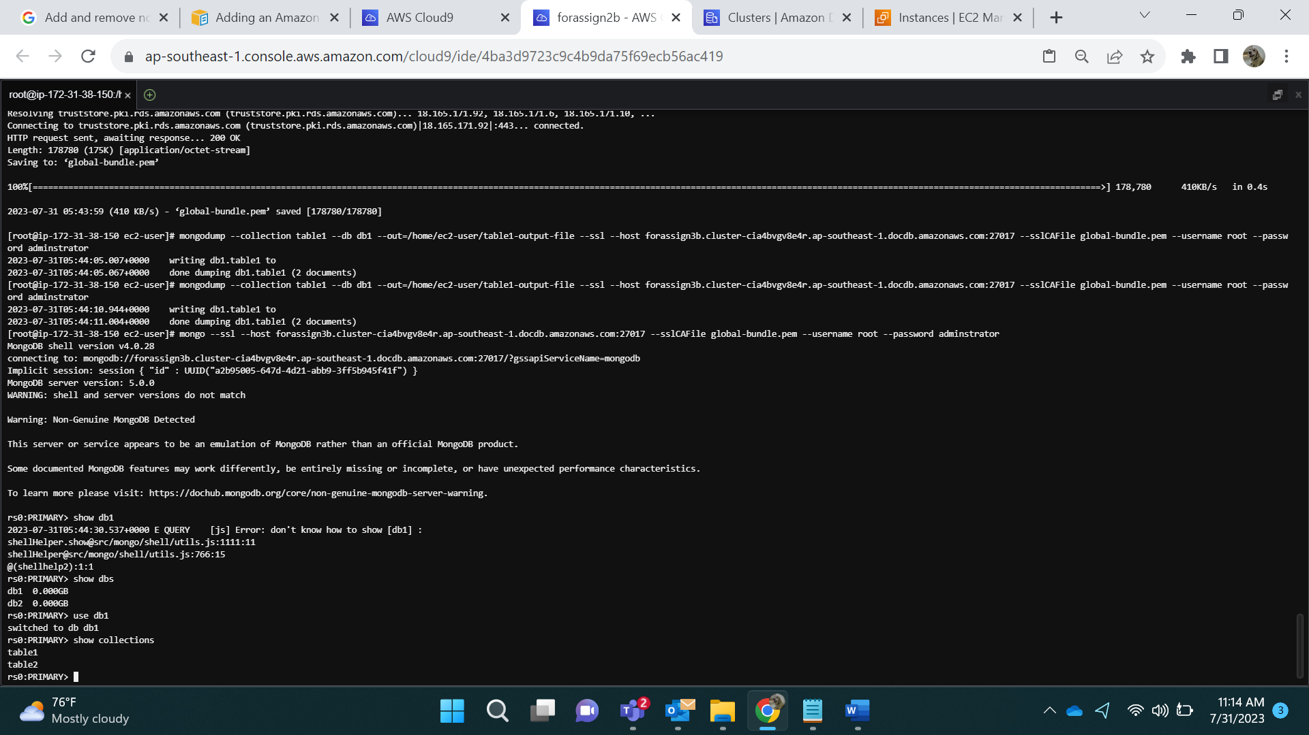

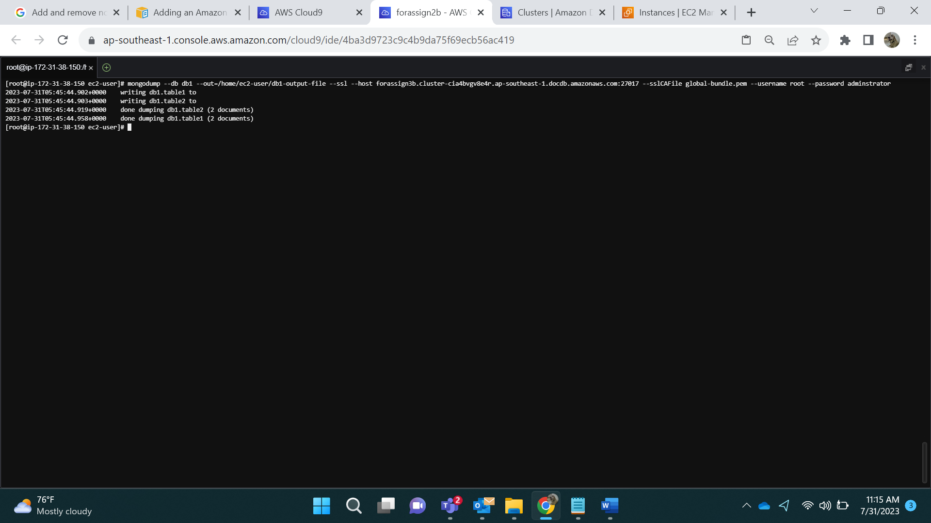

Location: Cd /home/ec2-user/db1-output-file/db1

ls

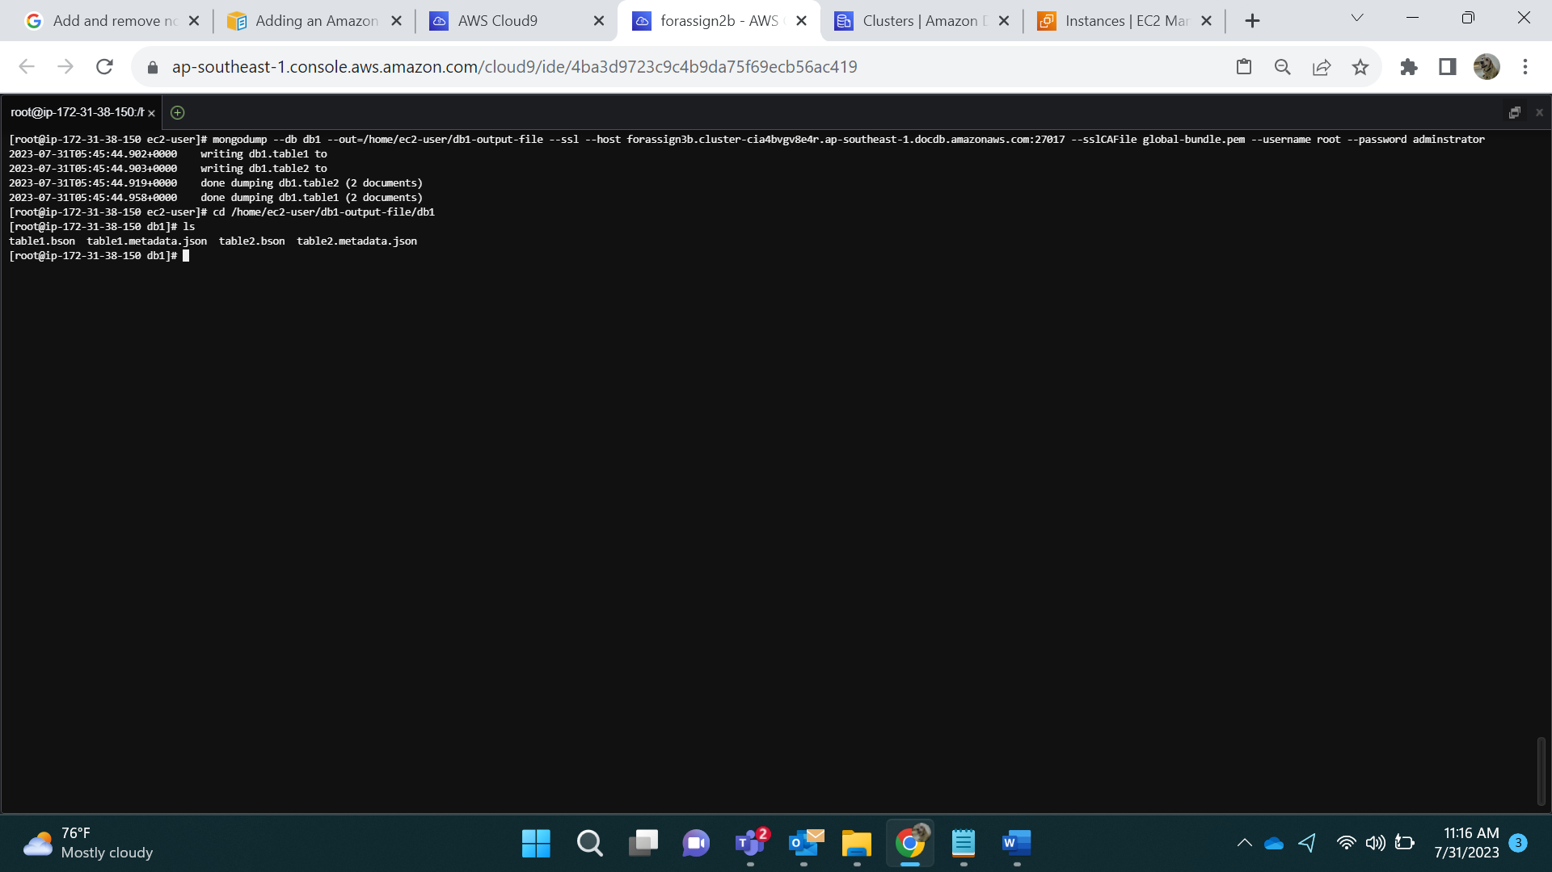

**Full database backup:**

mongodump --out=/home/ec2-user/db-file --ssl --host forassign3b.cluster-cia4bvgv8e4r.ap-southeast-1.docdb.amazonaws.com:27017 --sslCAFile global-bundle.pem --username root --password administrator

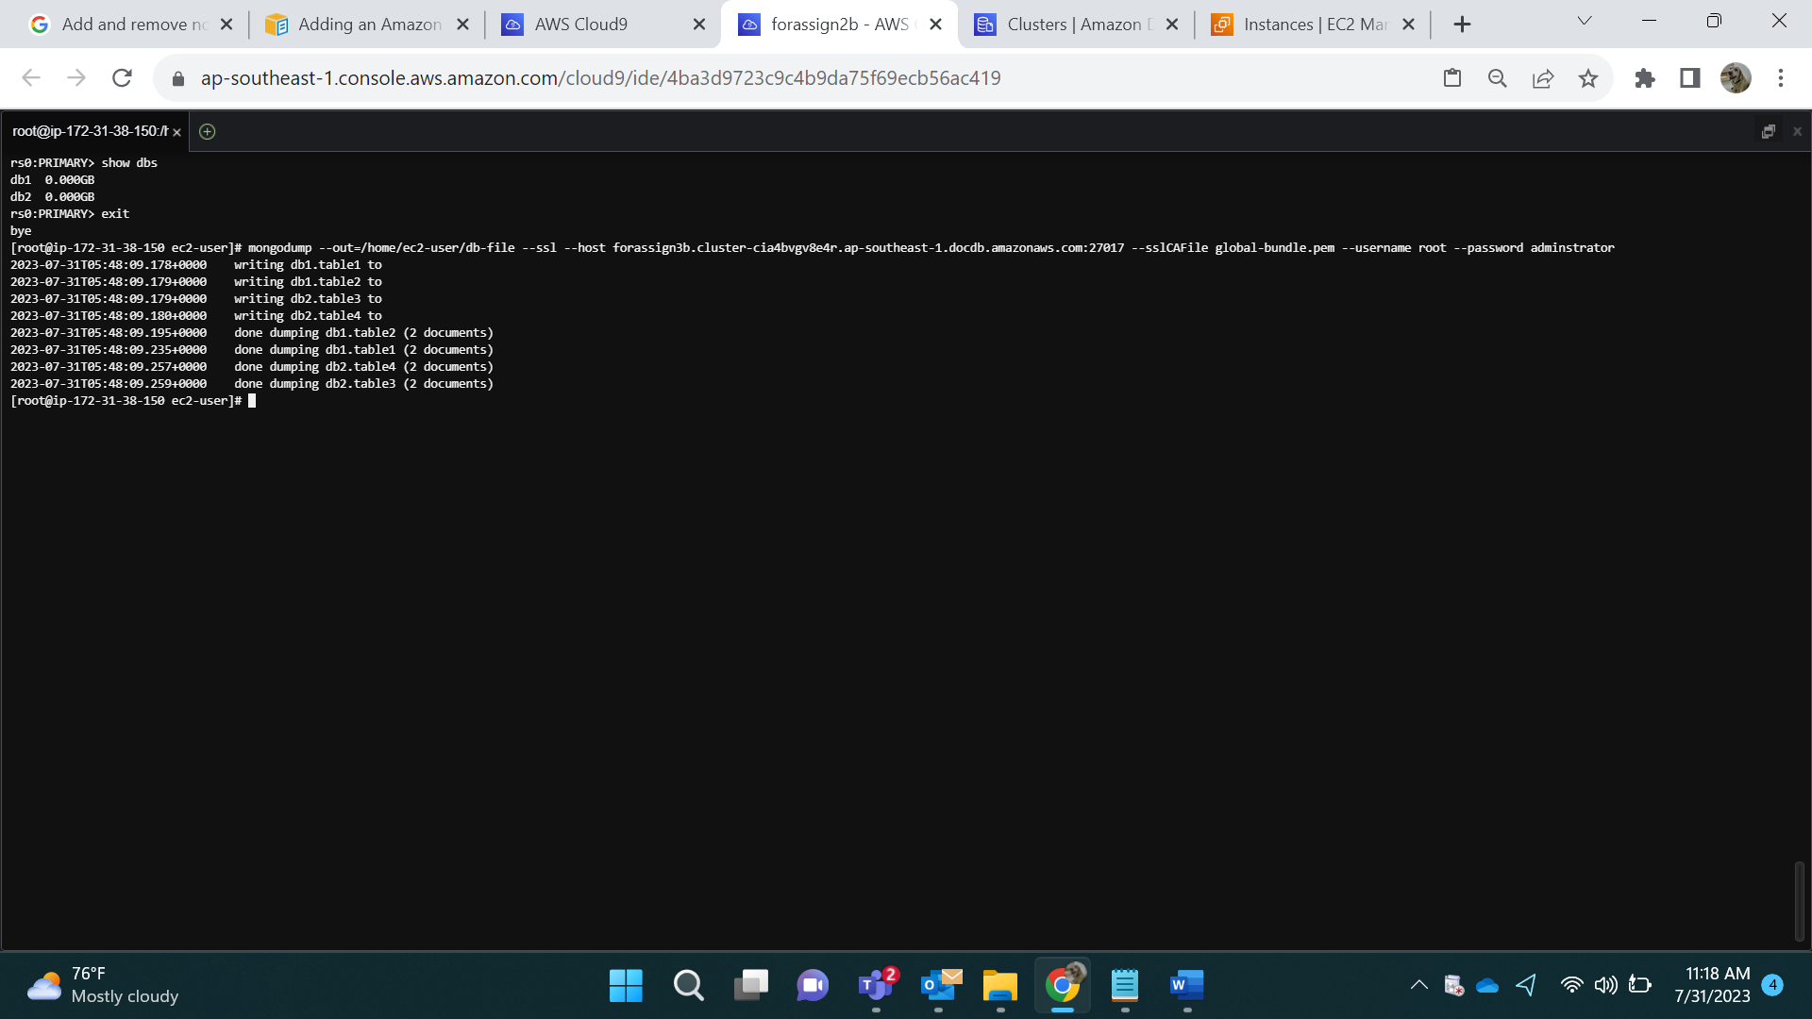

Location : Cd /home/ec2-user/db-file/db2

ls

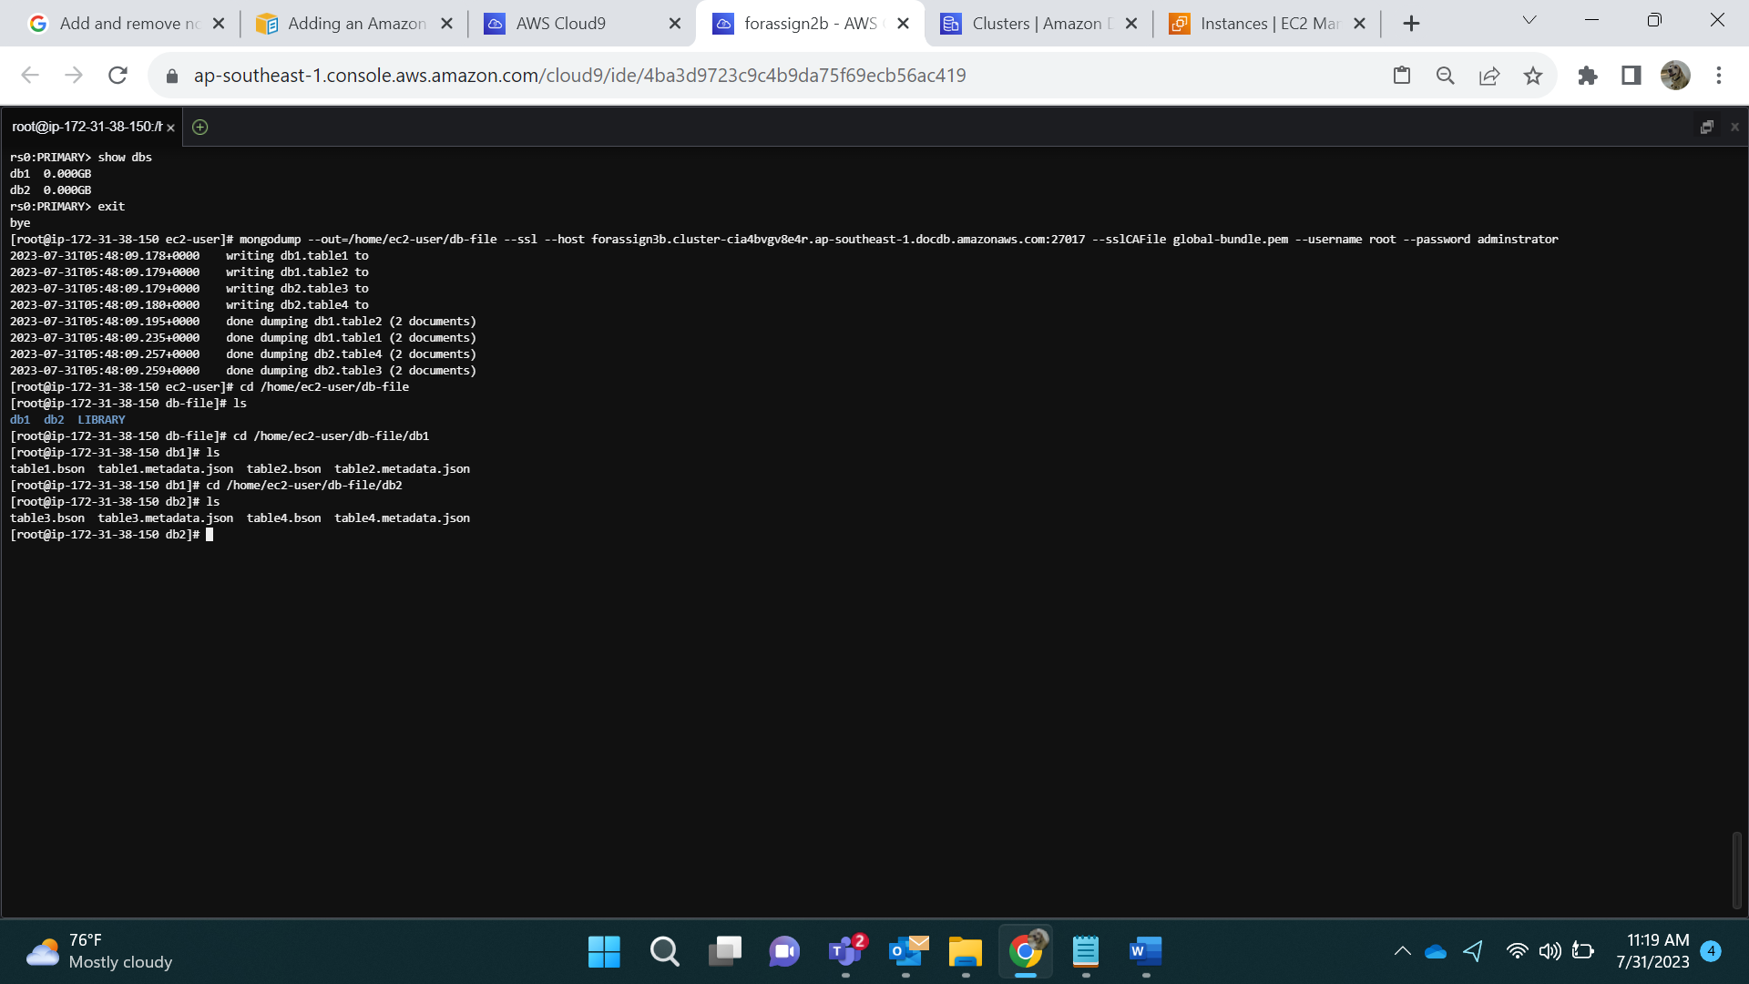

Before Dropping One Database:

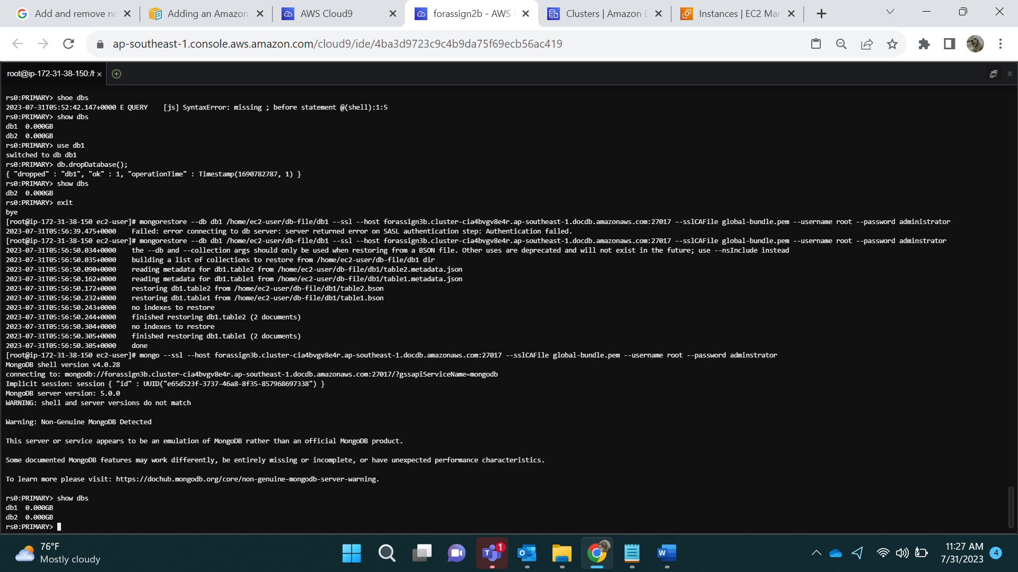

**How to Drop db1:**

Use db1

Db.dropDatabase();

show dbs;

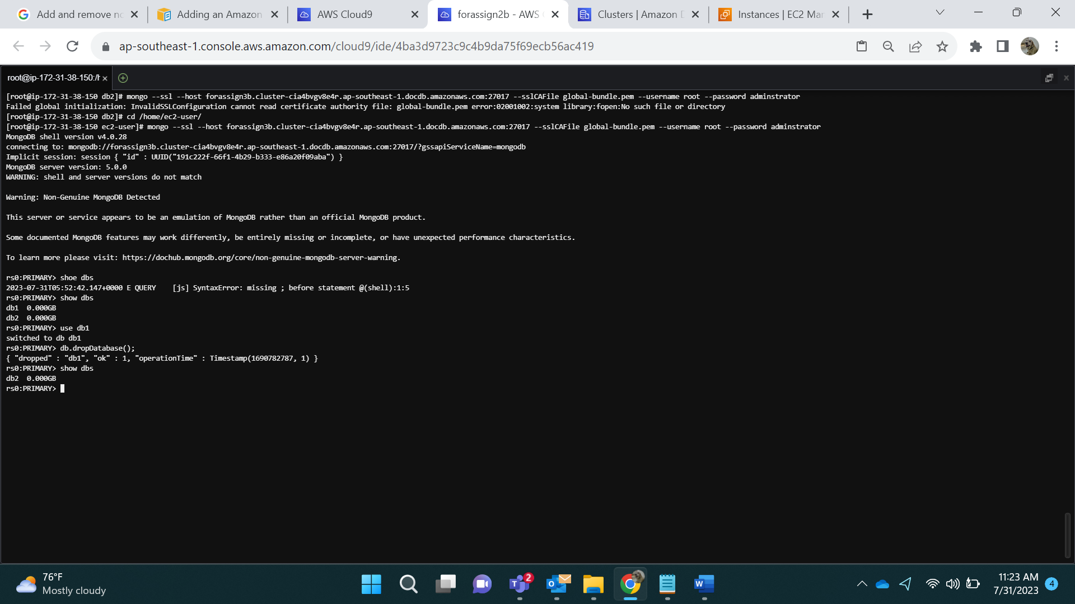

Show dbs

As mentioned, we cannot see db1

**Restore One Database:**

mongorestore --db db1 /home/ec2-user/db-file/db1 --ssl --host forassign3b.cluster-cia4bvgv8e4r.ap-southeast-1.docdb.amazonaws.com:27017 --sslCAFile global-bundle.pem --username root --password adminstrator

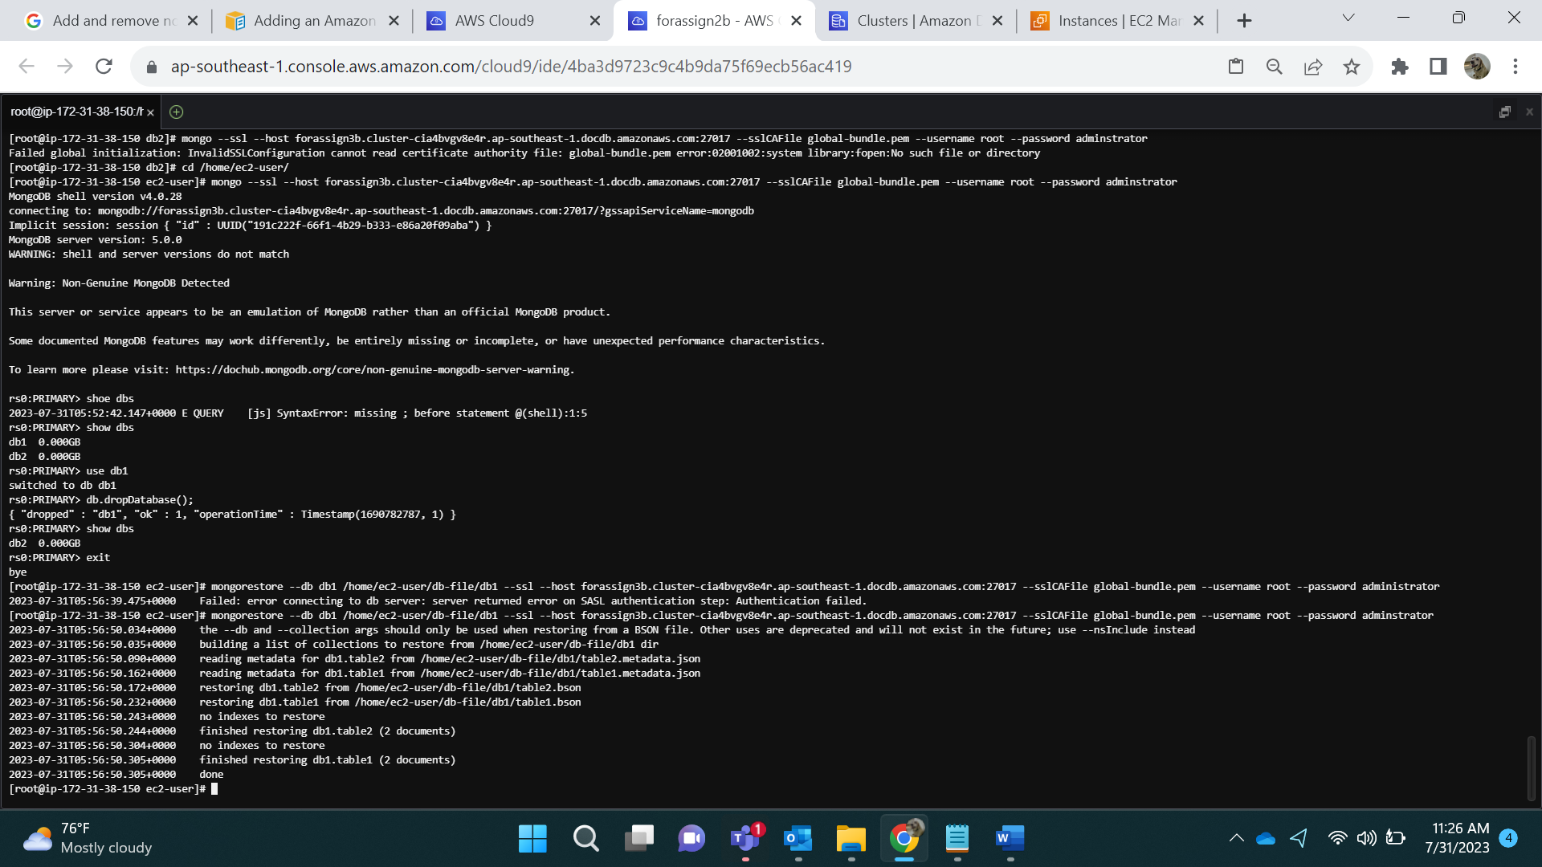

After Restoring:



Before Dropping both database:



**Drop Both Databases:**

Use db1

Db.dropDatabase();

Use db2

Db.dropDatabase();

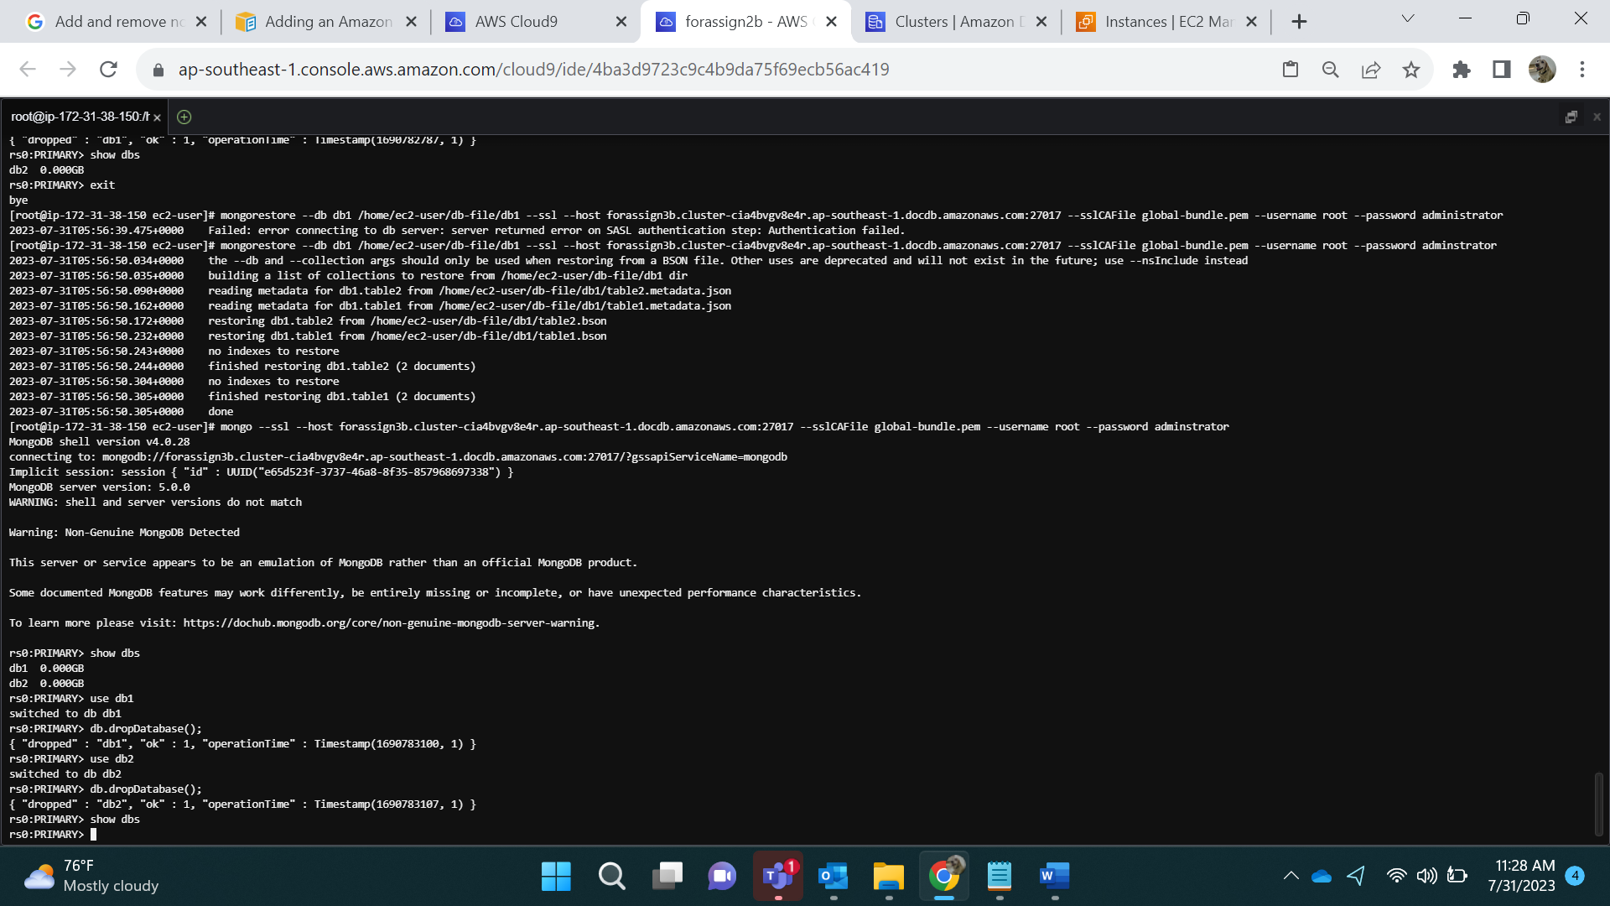

**Restore full Database:**

mongorestore /home/ec2-user/db-file --ssl --host forassign3b.cluster-cia4bvgv8e4r.ap-southeast-1.docdb.amazonaws.com:27017 --sslCAFile global-bundle.pem --username root --password adminstrator

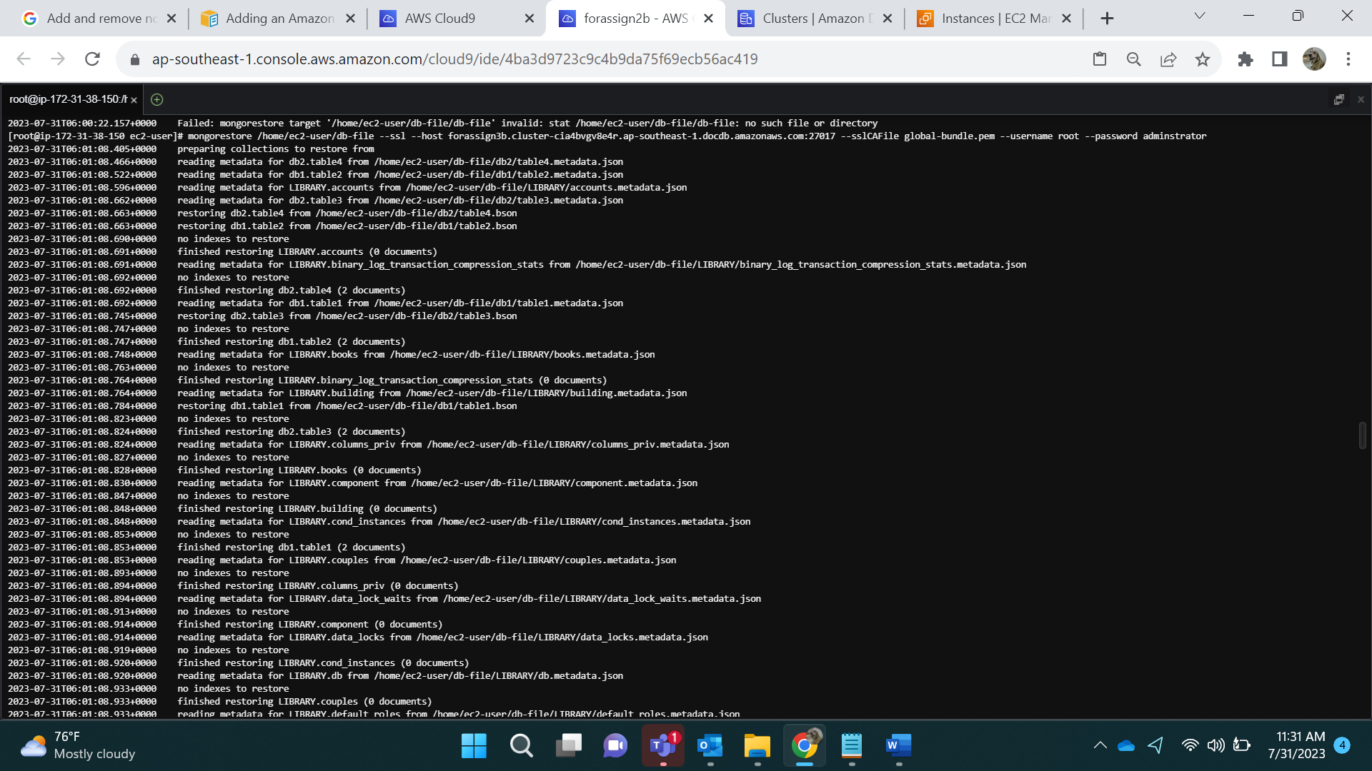

Login: mongo --ssl --host restore-forassign3b.cluster-cia4bvgv8e4r.ap-southeast-1.docdb.amazonaws.com:27017 --sslCAFile global-bundle.pem --username root --password administrator

**After Restore both database:**

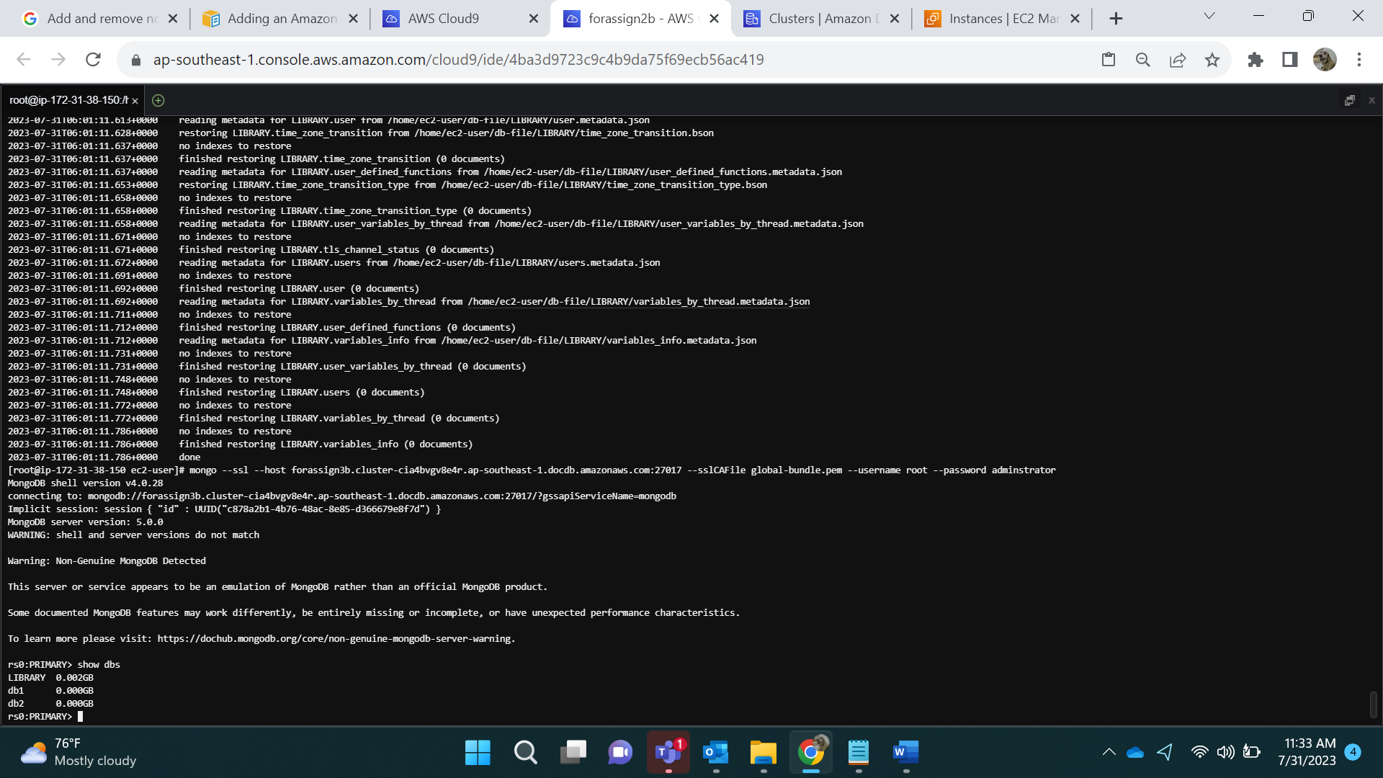

**Before Dropping collection:**

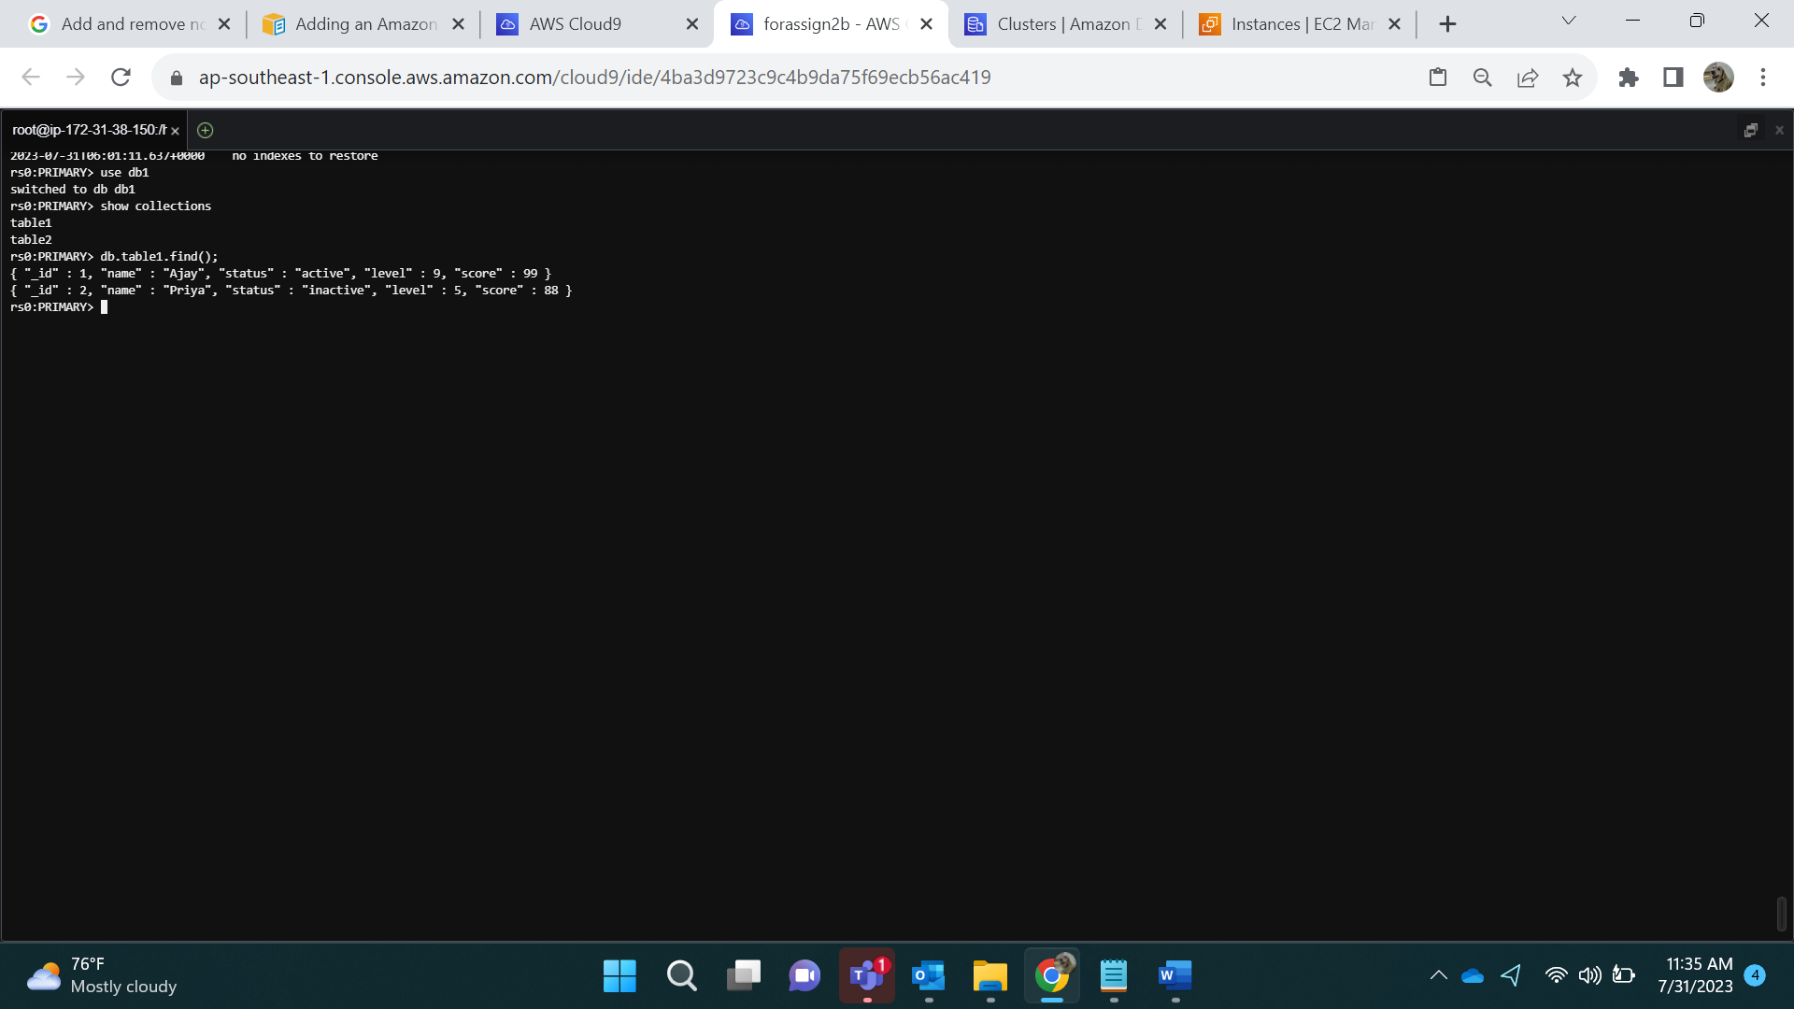

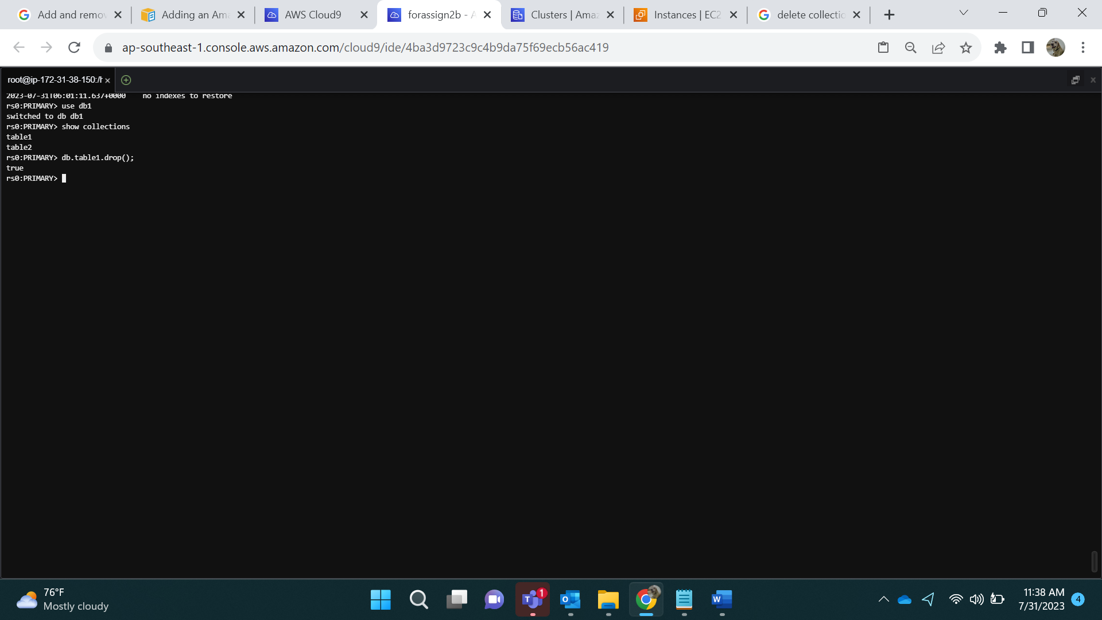

**Restoring the collection:**

mongorestore --collection table1 --db db1 /home/ec2-user/db-file/db1/table1.bson --ssl --host forassign3b.cluster-cia4bvgv8e4r.ap-southeast-1.docdb.amazonaws.com:27017 --sslCAFile global-bundle.pem --username root --password adminstrator

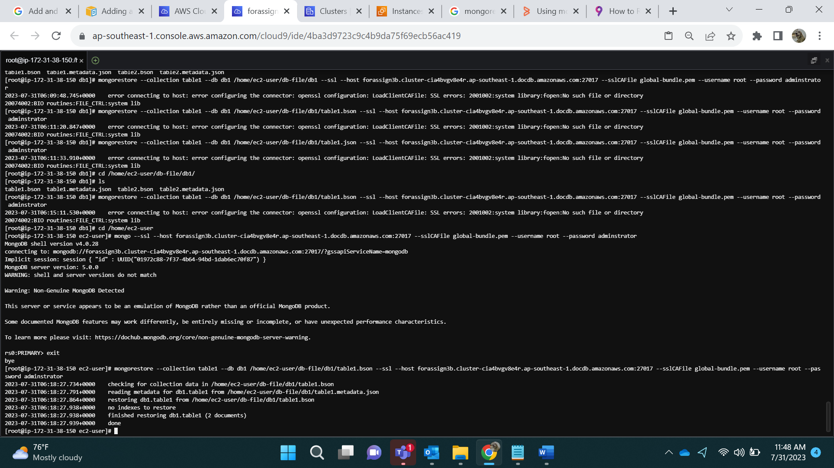

**After restoring collection:**

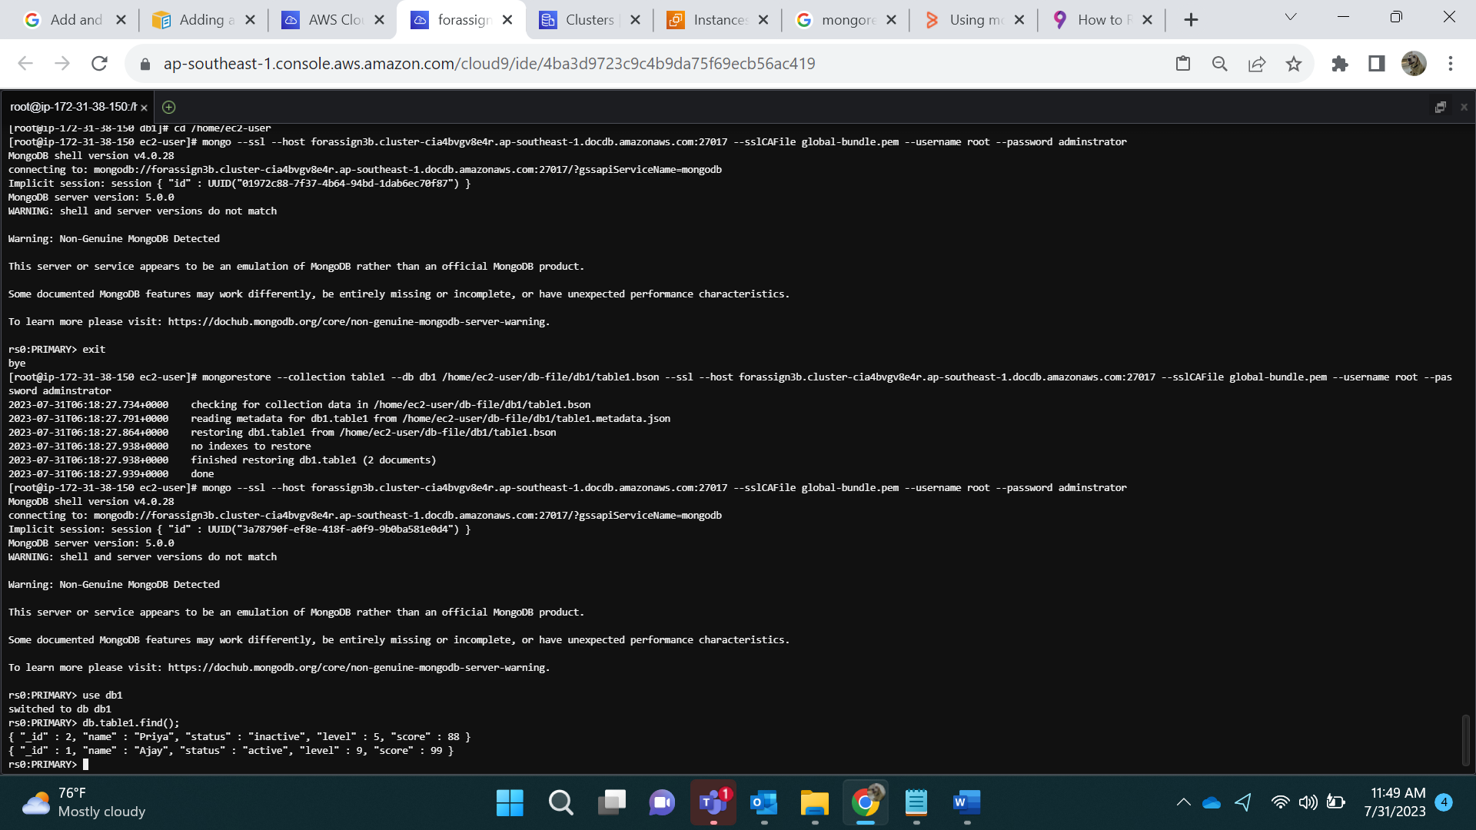

Mongo Export:

mongoexport --db db1 --collection table1 --type=json --out /home/ec2-user/table1.json

cd /home/ec2-user/

ls

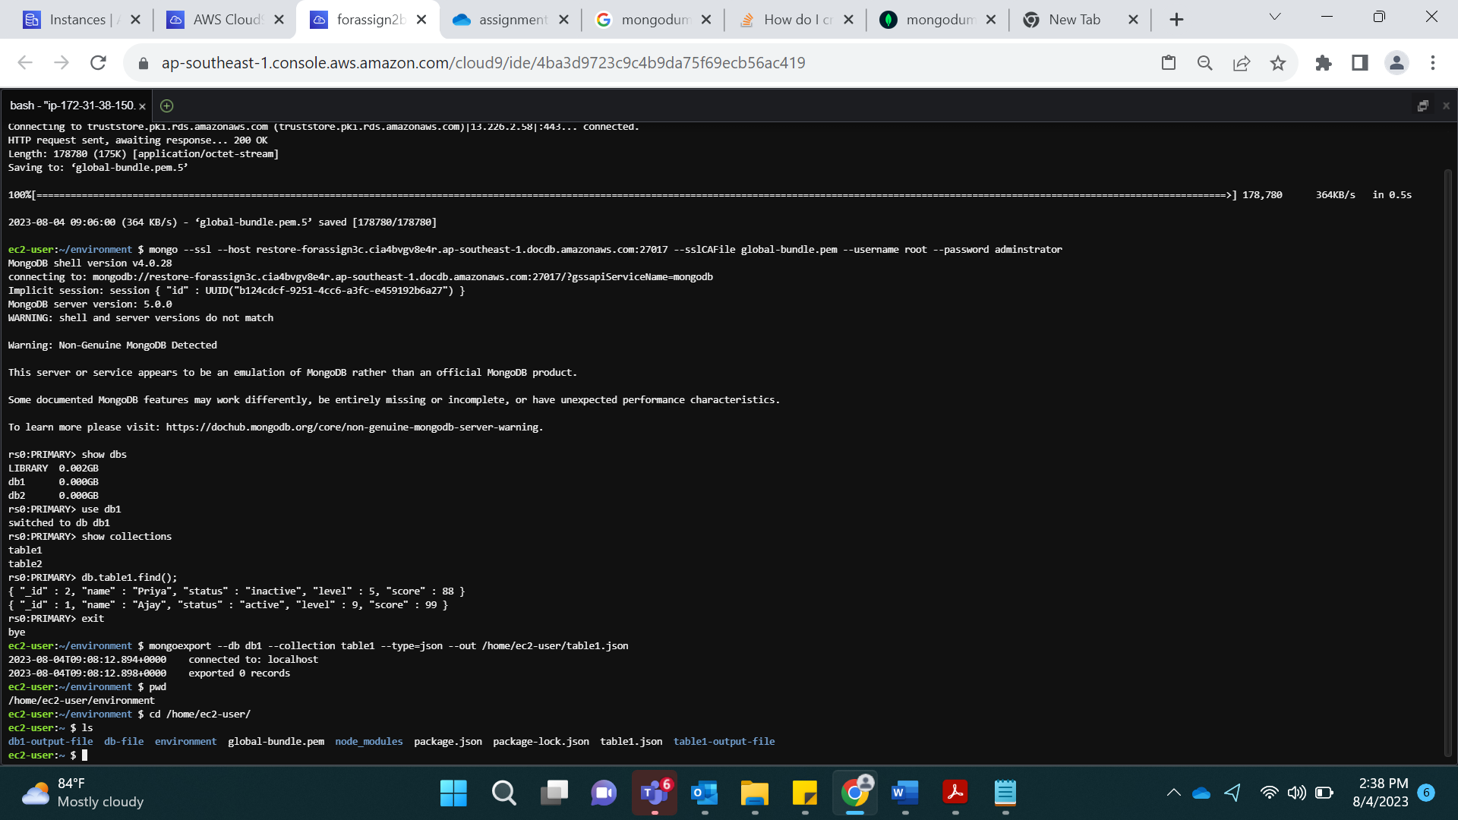

Mongo Import:

mongoimport --db db1 --collection table1 --type=json --file /home/ec2-user/table1.json

